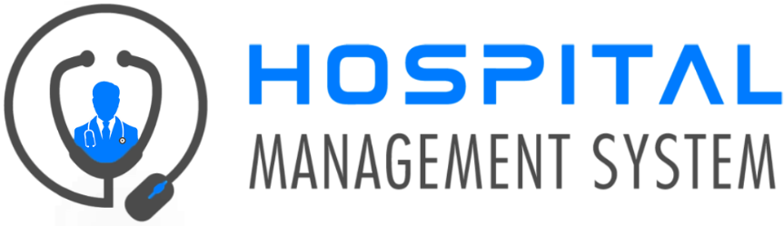

Requirement Document

**Group xx**

**Contribution**

TG/2020/672 – G.W.M.D. Rupasinghe

TG/2020/700 – J.M.N.R.D. Jayaweera

TG/2020/703 – K.A.D.P.M. Siriwardana

TG/2020/711 – H. M. M. A. Herath

TG/2020/723 – W.V.P.V. Karunasinghe

TG/2020/726 – M.K.K. Jithma

TG/2020/749 – H.P.G.L.P. Jayathilake

TG/2020/751 – N.W.V.B.S.B. Weragoda

DEPARTMENT OF INFORMATION AND COMMUNICATION TECHNOLOGY

FACULTY OF TECHNOLOGY

UNIVERSITY OF RUHUNA

**Hospital Data Management System**

## System Description

## Hospital Data Management System

Now a days many Private and Govt. corporations turn into digitalization. Organizations that deal with large amount of people are special among them. Large volumes of patient and clinical data are stored in healthcare IT systems. A software program called a Hospital Data Management System is used to plan and manage a clinic's daily operations. The hospital's financial, administrative, legal, and medical aspects are governed by HDMS. The volume of medical data sets grows as a healthcare organization scales, necessitating organized storage and simple access. It takes a lot of time and effort for staff to manually process information, which results in mistakes.

In our case, we mainly targeted about administrative works in a Hospital system. We get all the doctors, nursing staff, attendants as internal live environment and laboratories, wards as inanimate environment. HDMS connect all these hospitals internal environment as an interrelated system. Then their external environment is relationship with the patients. HDMS gives the ability to store and manipulate all the data about patients.

## **Requirements Analysis**

## Data Dictionaries

------------- END -------------